In the format for the submission for Advances in Biology Laboratory Education
ABLE FORMAT WITH INSTRUCTOR AND STUDENT TEXT

TEMPERATURE DEPENDENCE ON THE PASSIVE EFFECTS OF K⁺ ON MEMBRANE POTENTIAL OF SKELETAL MUSCLE AS AN EDUCATIONAL MODULE

By
Janki Naidugari¹, Dara Buendia Castillo^{1,2}, Mohammad Abou El-Ezz¹, Cameron Brown¹, Tom Calderaro¹, Cameron Evans¹, Trey Grant¹, Rachel Hazelett¹, Cassity High¹, Tessa Ilagan¹, Jack Klier¹, Nicole Marguerite¹, Felicia Marino¹, Shelby McCubbin¹, Nicholas Meredith¹, Blair Nethery¹, William Russell¹, Noah Sommers¹, Esther E. Dupont-Versteegden^{2,3}, Rebecca Krall⁴, Katherine Sharp⁴, Jeffrey Chalfant⁴, Mia Brown⁴, and Robin L. Cooper^{1,2}

¹675 Rose St, Department of Biology, University of Kentucky, Lexington KY 40506-0225 USA
²Center for Muscle Biology, 900 South Limestone, University of Kentucky, Lexington KY 40536-0200 USA
³Charles T. Wethington Jr. Building, 900 South Limestone, University of Kentucky, Lexington KY 40536-0200 USA
⁴Rm 105 Taylor Education Bldg, 597 S. Upper St, Department of STEM Education, University of Kentucky, Lexington, KY 40406-0001, USA

ABSTRACT
In modifying a typical physiological laboratory protocol in measures of the resting membrane potential in relation to the concentration of extracellular potassium ions [K⁺]_{o,} the additional effects of temperature were addressed. The effects of temperature on the membrane potential are not commonly addressed in experimental physiology and neurophysiology student laboratory exercises. In terms of presenting an authentic application of the experimental design, various topics were discussed with the class. This report presents how this was addressed for a neurophysiology laboratory course. Crayfish were used as models in empirically addressing the effects of temperature and [K⁺]_{o} change as one topic and a second focus was on clinical therapies related to the use of varied temperatures in mammals. A third topic focused on a unified issue with all organisms in temperature changes with cellular metabolism. Experimentally the skeletal muscle of a crayfish served as model to obtain data due to the robust nature of the preparation for student laboratories. Graphing membrane potential in relation to both [K⁺]_{o} and temperature along with theoretical curves for the Nernst and Goldman-Hodgkin-Katz (G-H-K) equations provided important distinctions and the relationship of temperature in these equations. Freely available online software was used in addressing the theoretical values one would expect for changing the variables in the G-H-K equation. Discussion of other factors impacted by temperature for biological membranes were also covered. A pre- and post-survey over general content and views on the activities was obtained.
Introduction
What is the purpose of undergraduate biology laboratory experiences, particularly in upper level coursework? The common laboratory exercise is designed around a traditional, “cookie cutter” lab where significant scaffolding characterized by step-by-step procedures resulting in a known outcome. Learners are then tasked with following the procedures to produce an outcome within an acceptable limit of error. What implicit message do these traditional laboratory experiences teach emerging biologists about the endeavor of science?
In his book, What Is Life? How Chemistry Becomes Biology, Addy Pross (2012) articulates the inductive nature of science. At its simplest form, he argues, “Ultimately all scientific explanations are inductive―they involve no more than the recognition of patterns and the association of the specific within the general. Broadly speaking the wider the generalization, i.e., the greater the number of empirical observations that are embraced by the generalization, the greater its predictive power and the more significant the generalization,” (p. 46). How do college students sharpen their inductive skills to discern patterns in the data and translate and then apply knowledge from the research literature to construct explanations or refute claims if they are only participating in traditional laboratory activities?
Inspiring curiosity and engaging learners, particularly underrepresented learners in science
The exercise presented in this paper is designed to provide alternative tweaks to a standard protocol for novel investigative purposes. Hopefully, this will engage more participation in learning the related content as well as enjoyment in conducting a laboratory exercise. We refer to this type of class exercise as an Authentic Undergraduate Research Experience (ACUREs) as these allow novel projects to be developed with a goal in publishing the findings and offering students an advanced scientific undertaking by publishing their results. In the past, this general lab in the resting membrane potential with varied extracellular concentration of potassium ions (i.e. [K⁺]_{o}) was taught in the concept of muscle or neuronal injury and spillage of K+ adding to [K⁺]_{o}. (Cooper et al., 2019). However, an additional twist is using homogenized muscle (i.e., muscle juice) at various dilutions and examining the membrane potential (Thenappan et al., 2019). An additional perturbation which students had an interesting experience conducting was to add the effects of muscle juice on evoked synaptic transmission and the occurrences of spontaneous quantal events as well as shapes in the evoked and single quantal events (Thenappan et al., 2019). The preparation used offers unique experimental outcomes and potential follow up experimentation. For example, since crayfish and many insects use glutamate as the neurotransmitter at the neuromuscular junction, the glutamate receptors become desensitized during the muscle juice application which is likely due to the amount of glutamate within the homogenized muscle. Thus, the evoked and spontaneous quantal events become smaller than are observed for the same amount of muscle depolarization due to reducing driving gradient of the Na⁺ influx through the inotropic glutamate receptor with the raised [K⁺]_{o}. This resulted in students designing new experiments with raised [K⁺]_{o}. and adding in small amounts of glutamate to mimic the responses observed with the muscle homogenates. In addition, the concepts of raised [K⁺]_{o} within one class were expanded to the whole organism, then to the effects on other cells (i.e. peripheral sensory neurons) besides the ones in proximity to the muscle fibers as an ACURE project to the point of publishing novel results (Malloy et al., 2017).
To assess student learning outcomes in conducting this module, we used a modified survey presented in Thenappan et al., (2019) to focus on the effects of temperature on the relationship with biological membranes in addition to the effects of changes in ionic composition of intra- and extra-cellular fluids. In addition, the survey asked open responses on their views of the activity.
Here, we present a detailed protocol along with student theoretical evaluations and empirical data from the experiment. Data will be provided on a web page as well as supplemental information for instructors to use in in hybrid or remote teaching in case the hands-on experimentation in a laboratory is not possible. Instructors can have students graph the data sets and discuss the findings.
Student protocol
Objectives
The students will learn:
1. How to take intracellular recordings from muscle fibers.
2. How varying [K⁺]_{o} effects on the membrane potential theoretically and experimentally.
3. How temperature effects the membrane potential theoretically and experimentally.
4. How to graph the theoretically and experimentally obtained data and make comparisons.
5. The practical application of the knowledge in how varying [K⁺]_{o} and/or temperature effects the physiology of cells, tissues and whole organisms.
INTRODUCTION
A common student physiology laboratory protocol for teaching content on the resting membrane potential is generally to vary the extracellular potassium ions [K⁺]_{o} in relation to the membrane potential. In experimentally determining this relationship, participants will vary the [K⁺]_{o} while taking measures of the membrane potential with intracellular recordings. The experimentally obtained values are to be plotted in relation to the theoretical Nernst equation. The deviation in the curves would likely bring up the topic of the Goldman-Hodgkin-Katz (G-H-K) equation and why the G-H-K equation is a better fit for the experimentally obtained data (Atwood and Parnas, 1968; Baierlein et al., 2011; Johnson et al., 2014; Wyttenbach et al., 1999).
This exercise is focused on a novel approach with combining the standard membrane potential and raised [K⁺]_{o} paradigms to include the effect of temperature on the membrane potential. In this exercise, theoretical graphs of membrane potential and the relationship with variation of [K⁺]_{o} are to be made with an on line program. The effect of temperature in relation to the curves is also to be calculated and discussed. Experimentally, students will measure membrane potentials in a muscle of crayfish and vary [K⁺]_{o} at various temperatures. The experimental data will be graphed and compared with the computationally obtained data for group discussion.
Relating this integrative topic to real world applications, three general themes are presented for one to contemplate. The first theme is to address the topic with heterothermic animals, such as crustaceans and insects, which can be exposed to wide variations in temperature abruptly as compared to seasonal changes or longer-term climate change. In addition, addressing a true hibernating mammal, such as a squirrel, and the effects on cells within this animal are also discussed. The second theme is to address the potential implications with clinical therapies, such as a cold or warm pack on injured tissue and cold induced coma for reducing neural and heart function. In addition, a third theme in the commonalty regarding heterotherms and homeotherms with cellular metabolism which results in thermal changes.

MATERIALS AND METHODS
Theoretical calculations empirical measures of membrane potential

To begin this exercise the Nernst equation and Goldman-Hodgkins-Katz equation (GHK) need to be addressed.
Equations that are commonly used to determine the equilibrium potential of an ion and resting membrane potential are the Nernst equation and the Goldman-Hodgkin-Katz (G-H-K) equation, respectively. An important distinction between the two equations is that the Nernst equation is used only for one specific ion to determine the equilibrium potential for that ion, whereas the G-H-K equation is used to determine the resting potential by considering the permeability of multiple ions and their gradients across a cell membrane (Nernst, 1888, 1889; Goldman, 1943; Hodgkin and Huxley, 1952; Hodgkin et al., 1952; Hodgkin and Katz,1949; see Hille, 1992).

The Nernst equation is generally considered for ions across a membrane generating an electromotive force as commonly shown as:
$$V=\frac{RT}{zF} ∙ln\frac{⁡{[X]}_{out}}{{[X]}_{in}}$$

X = ion of interest
V = equilibrium voltage for the X ion across the membrane
R = gas constant [8.314 J/(mol•K)]
T = absolute temperature [Kelvin]
Z = valence of the ion
F = Faraday's constant [9.649 × 104 C/mol]

For the K⁺ ion at 20ºC and transformation of ln to log₁₀ along with filling in the constants, one arrives at:
$$Potential=58 log\frac{{[K]}_{out}}{{[K]}_{in}}$$

Let us assume that only K⁺ is permeant by diffusion. [K_{in}] is the K⁺ concentration on the inside of the cell and [K_{out}] is the K+ concentration on the outside of the cell.

As an exercise estimate [K_{in}]. ______________

Assume for this calculation, membrane potential is only dependent on the K⁺ equilibrium potential.

Given the [K]_{out} = for the saline used is 5.4 mM. Also, assume membrane potential is -70mV.

$$Potential=58loglog \frac{5.4}{{[K]}_{in}}$$
-70/58=log 5.4/[K in]
-1.2069= log 5.4/[K in]
Antilog -1.2069= 5.4/[K in]
10^{-1.2069}= 5.4/[K in]
0.0621= 5.4/[K in]
[K in] =5.4/0.0621=86.95 mM
Double check
X= 58 Log (5.4/86.95)= -69.999 so close enough to -70 mV
Considering that a membrane can be permeable to more than one ion at rest, as well as at various depolarized states, one uses the G-H-K equation to take into account the permeability (P in the equation) for various ions. The G-H-K equation will reduce to the Nernst equation if a membrane is permeable to only one ion.

Here is a generalized G-H-K equation for Na⁺, K⁺, and Cl⁻ ions:

$${Em}_{K, Na, Cl}=\frac{RT}{F}lnln \frac{P_{{Na}^{+}}{\left[{Na}^{+}\right]}_{out}+P_{K^{+}}{\left[K^{+}\right]}_{out}+PCl[Cl]in}{P_{{Na}^{+}}{\left[{Na}^{+}\right]}_{in}+P_{K^{+}}{\left[K^{+}\right]}_{in}+PCl[Cl]out}$$

Since Cl⁻ has a negative charge, the concentration term is inverted in this equation for the inside and outside. This allows the Z (ion charge) to be left off.

A free software database allows one to put in different values for temperature and other variables in the G-H-K equation for a quick response in the expected membrane potential. The use of the rapid computer simulation helps to demonstrate the effect of the various parameters on the membrane potential as well as how slight changes in one parameter can have a large role in the outcome.
The main emphasis for this exercise is on how different temperature values and [K⁺]_{o} affects the membrane potential.
Given the values reported in the literature for crayfish muscle use these as a reference. The concentration of K+ in the saline to start off with is 5.3 mM and the temperature is 21 C (Note: One needs tol take the temperature of the saline in which the experiments are to be conducted in practice).
There are values estimated for neurons of crayfish (Atwood 1982) which are to be used along with those obtained for muscle fibers.
[Na⁺]_{i} = 17.4 mM (for neurons, Atwood 1982)
[K⁺]_{i} = 265 mM (for neurons, Atwood 1982)
[Cl⁻]_{i} = 12.7 (for neurons, Atwood 1982)
P_{K} = 1 (for neurons, Atwood 1982)
P_{Cl} = 0.1 (for neurons, Atwood 1982)
P_{Na} = 0.001 (for neurons, Atwood 1982)

For crayfish muscle:
“Procambarus and Astacus [K⁺]_{i} appears to be 171 and 167 mM, respectively.” (Katz et al., 1972). One will use the values for Procambarus since this is the genus being used.
[K⁺]_{i} = 171 mM (determined for crayfish muscle)
[K⁺]_{o} = 5.3 mM (Saline)
[Na⁺]_{i} = 17.4 mM (assume for muscle)
[Na⁺]_{o} = 205 mM (Saline)
[Cl⁻]_{i} = 12.7 mM (assume for muscle)
[Cl⁻]_{o} = 232.15 mM (assume from saline; 205 mM NaCl; 5.3 mM KCl; 13.5 mM
CaCl₂2H₂O; 2.45 mM MgCl₂ 6H₂O)

P_{K} = 1 (assume for muscle)
P_{Cl} = 0.01 (assume for muscle)
P_{Na} = 0.001 (assume for muscle)

Use the on-line simulator from
Online https://www.physiologyweb.com/calculators/ghk_equation_calculator.html
(note: values of temperature are in K which is 273.15 + the # in centigrade)
Graph the results obtained from the online simulation for membrane potential based on the above values and for 5.3 mM, 10 mM, 20 mM, 30 mM, 40 mM, and 50 mM for [K]_{o} and using 5ºC, 10ºC, 21ºC, and 30ºC . Plot in a similar manner to those obtained for the barnacle muscle (Figure 1; copied from Fischbarg, 1972; https://doi.org/10.1113/jphysiol.1972.sp009886).
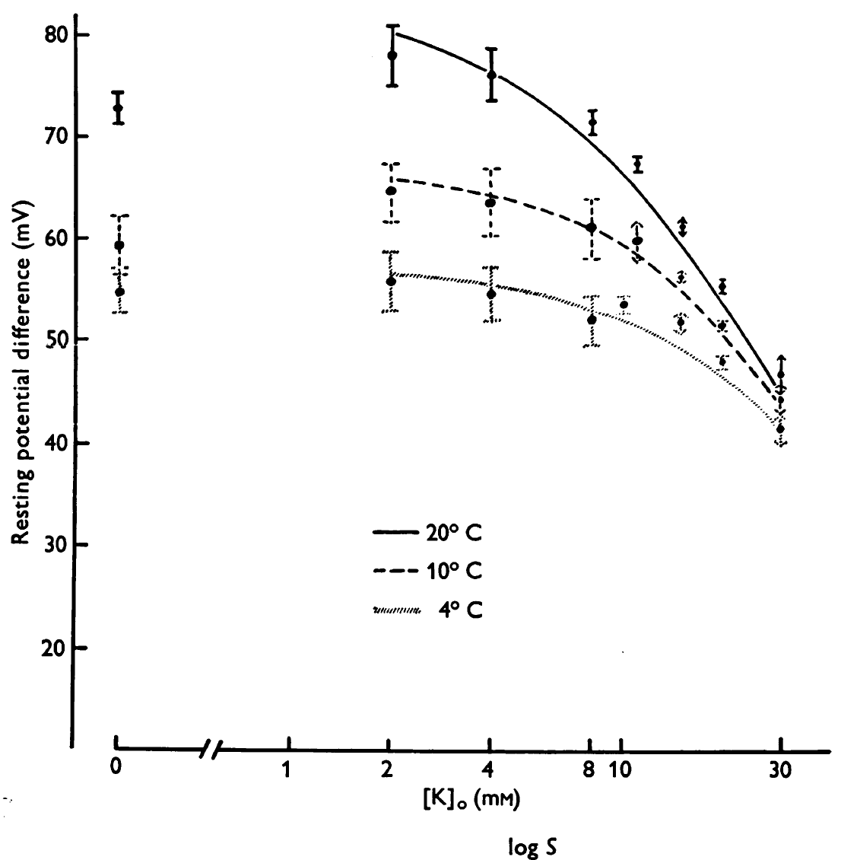
Figure 1: The effect of extracellular K⁺ and temperature on the membrane potential in barnacle muscle. Copied with permission from Fischbarg (1972). Note the Y-axis is a change in the membrane potential becoming more negative with reduced extracellular K⁺ and higher temperature. https://doi.org/10.1113/jphysiol.1972.sp009886
Experimental measures
To obtain the experimental data, one will measure in muscle fibers from a freshly dissected crayfish with sharp intracellular electrodes while changing the surrounding environment. Crayfish are used as the experimental organism as they survive for long periods of time with minimal saline composition.
The [K⁺]_{o} and temperature values are varied and the data is to be plotted and compared against the curves that was obtained from the computer simulations above.

METHODS

Materials for 1 set up

- Scissors (1)
- Forceps (1)
- Silver Wire for ground wire (1)
- Microscope (1)
- Electrode Probe (1)
- Petri Dish with Sylgard on the bottom (1)
- Saline Solution (1)
- Potassium Solutions: 5.4mM (normal saline), 10, 20, 40, 80, 100 mM
- Bleach (Small Amount, use for the tip of the silver wire to build Ag-Cl)
- Bulb Pipette (1), to remove and add solutions
- Syringe (1)
- Amplifier/Acquisition System (1)
- Faraday Cage (1)
- Desktop/Laptop (1)
- Dissection pins (4)
- Crayfish (1)

Preparation/Dissection:

1. A crayfish approximately 6-10 cm in body length should be obtained (or a manageable size). Hold the crayfish at the back of the head or approximately a centimeter from the back of the eyes. Ensure that the claws of the crayfish or its mouth cannot reach the individual handling the crayfish. (The crayfish may be placed in crushed ice for 5 minutes to anesthetize it prior to removing the head).

2. Once anesthetized, remove the crayfish from the ice and use the large scissors to quickly remove the head. Make a clean and quick cut from behind the eyes of the crayfish. Dispose of the head and appendages.

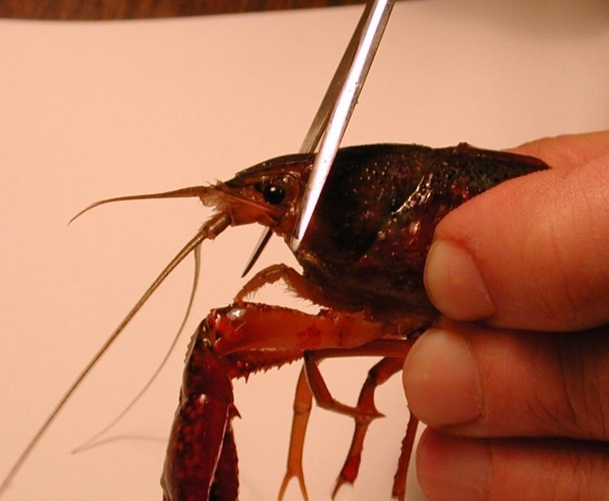
Figure 2: Image shows placement of the cut to remove the head of the crayfish.

3. The legs and claws of the crayfish can be removed at this point to avoid injury. Stylets on males and swimmerets on both males and females can also be removed (Figure 3). Next, separate the abdomen from the thorax. Make a cut along the articulating membrane, which joins the abdomen and thorax (Figures 4 and 5). Save the abdomen portion of the crayfish and dispose of the thorax.

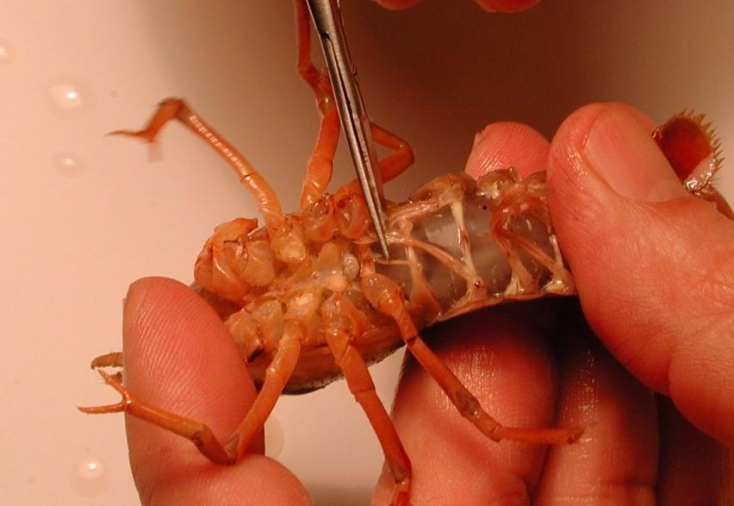
Figure 3: The scissors are cutting the stylets. These can be removed from the crayfish.
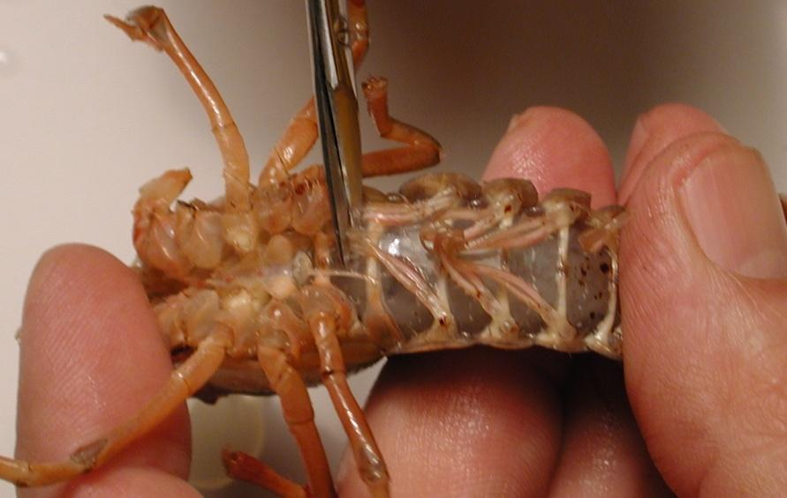
Figure 4: Image shows the placement of the cut to remove the thorax from the abdomen.
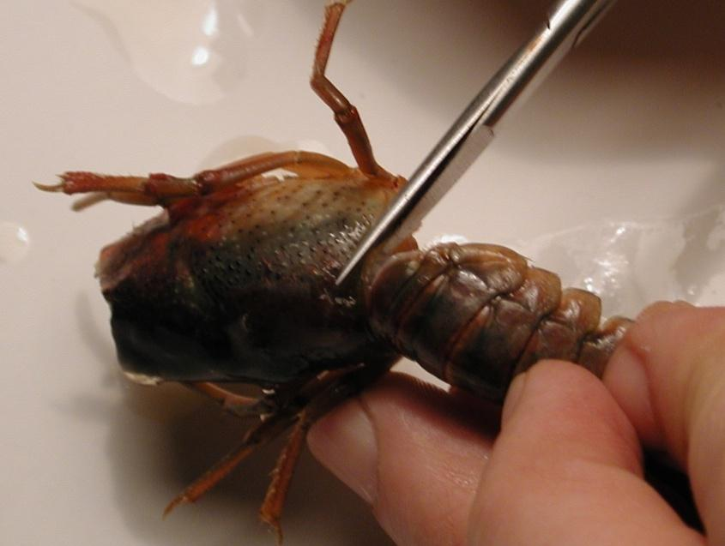
Figure 5: Removal of the thorax from the abdomen. The cut should be made in circular fashion along the line in the joining of the segments.
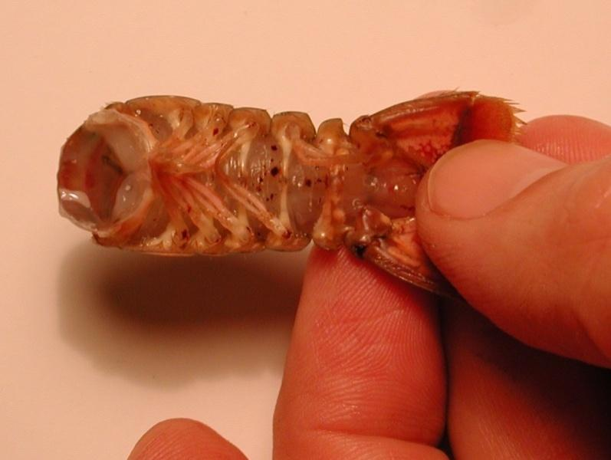

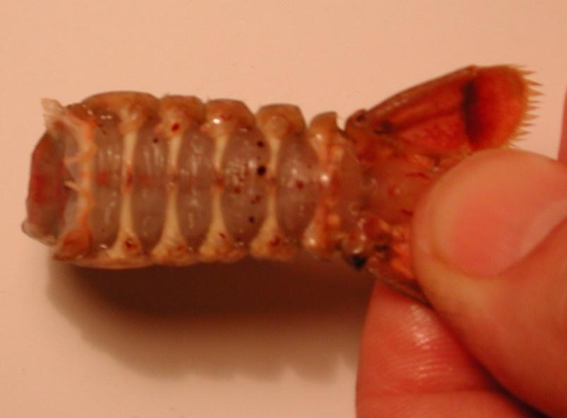
Figure 6: The top image shows the abdomen with swimmeret appendages. Bottom image shows the abdomen without the swimmeret appendages.

4. With the abdomen, a cut should be made in the shell along the lower, lateral border of each side of the abdomen. Care should be taken not to cut too deeply into the crayfish. To help in the process of cutting the shell, the cut should be made with the scissors pointing slighting down towards the ventral side and at an angle. Follow the natural shell pattern of lines of the crayfish that run the length of each segment (Figure
7).
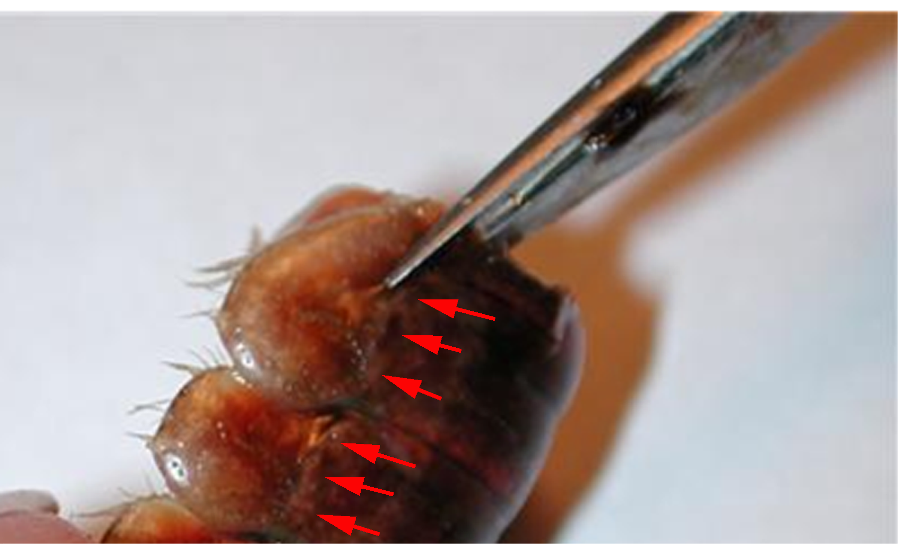
Figure 7: Scissors are placed at an angle and follow the natural alignment of the shell. Do not cut too deep and destroy the preparation. The arrowheads point to the natural line along each segment that should be followed for the cuts.

5. Remove the ventral portion of the shell. Take care not to destroy the abdominal muscles. Use forceps to remove the ventral portion. When the ventral portion of the shell is removed, a white mass of tissue can be seen on top of the deep flexor muscles. This tissue can be removed carefully with forceps.
Figure 8: Removing the ventral portion of the shell with forceps. Pull up and back on the ventral portion to remove. Do not destroy muscles under the ventral shell.

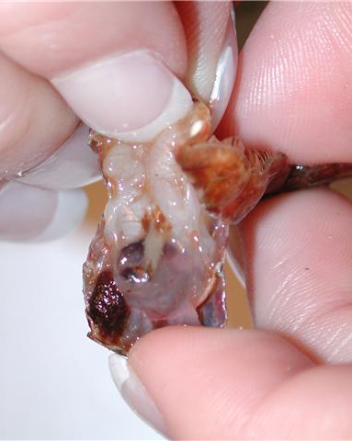
Figure 9: Pulling back on the ventral portion of the shell, which is to be discarded.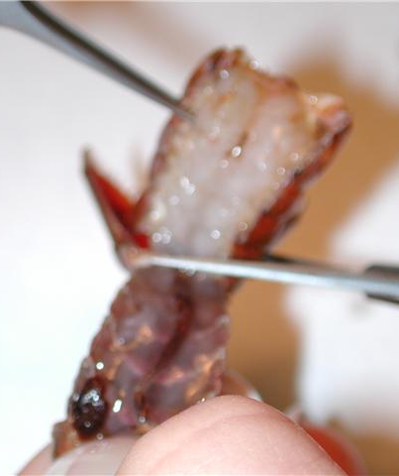
Figure 10: Cut the ventral portion of the preparation with scissors and discard.

6. The GI tract (Figure 11), a small tube running along the midline of the deep flexor muscles, can be removed from the crayfish. Pinch the top of the tract with the forceps and pull away from the abdomen. Cut the bottom of the tract – at the end of the tail. Rinse the dissection with saline to ensure the fecal waste does not interfere with the preparation.
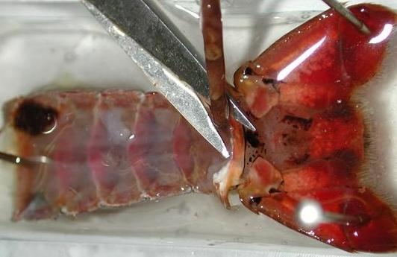
Figure 11: Image shows the removal of the GI tract from the preparation.

7. Use dissection pins to secure the preparation to the Petri dish. The top and bottom corners of the preparation should be pinned down to the dish. To help with inserting the glass electrode into the muscle cells, slightly angle the preparation on its side and pin down. This will make movements with the micromanipulator easier (see figure 13). Saline solution should be poured into the Petri dish and cover the preparation completely until intracellular recordings are performed.

This dissection dish should have a Sylgard (Dow Corning) coating on the bottom (1cm thick) so that insect pins can be stuck into it.

Dissected preparations are bathed in standard crayfish saline, modified from Van Harreveld’s solution (1936), which is made with 205 NaCl; 5.3KCl; 13.5 CaCl₂; 2H₂O; 2.45 MgCl₂; 6H₂O; 5 HEPES and adjusted to pH 7.4 (in mM).

Intracellular Recording
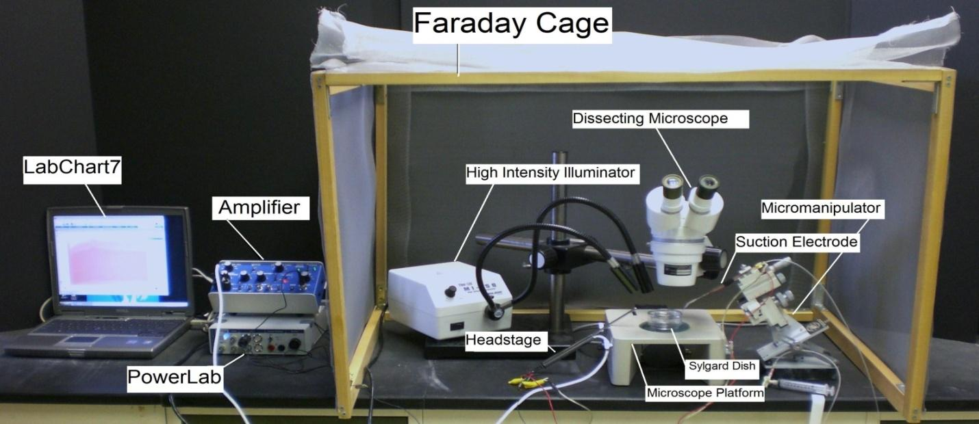
Figure 12: General setup of the recording equipment from. Specific set-ups may vary with different electrodes.

8. The specimen dish with preparation should be placed under the microscope and secured with poster tack beneath the dish to prevent movement.

Figure 13: Placement of the preparation under the microscope. Use poster tack (shown in blue) to secure the specimen dish and ground wire to the stage of the dissecting scope.

9. Two wires each with a short length of silver wire attached to one end should be obtained. The silver wire should be dipped into a small amount of bleach for about 20 minutes to obtain an Ag-Cl coating. Wash the wire with distilled water before using. A glass intracellular pipette should be obtained and carefully backfilled with a long needle attached to a syringe filled with a 3M KCl solution. The pipette should be turned down (sharp end pointing towards the ceiling) and filled with solution. This will ensure that any excess KCl will drip out the back of the electrode. Be sure no KCl runs along the glass pipette that will enter the saline bath. If KCl does spill over to the tip toss that one out and fill a new electrode. Turn the pipette upright when finished filling with potassium chloride solution. The silver wire can then be placed into the pipette (take care not to twist the pipette as it can break inside of the microelectrode). Intracellular recordings of resting membrane potentials used sharp glass electrodes (catalogue # 30-31-0 from FHC, Brunswick, ME, 04011, USA) filled with KCl (3 M) to obtain a 20-40 MΩ resistance were used. An agar bridge (1.5% agar in normal crayfish saline) was used to keep the electrical potentials from fluctuating when the saline was exchanged. The agar bridge was made with standard plastic Eppendorf pipette tips (200 μl) by using the small tip opening placed in the saline and the ground wire placed into the agar. A standard intracellular amplifier (A-M Systems, model 3000) was used which was bridged to a computer with an analog digital board (Power lab, model 26T, ADInstruments, Colorado Springs, CO). The signals were recorded and analyzed via Scope and LabChart software (ADInstruments, Colorado Springs, CO).

Figure 14: Microelectrode assembly with glass capillary in place.

The intracellular amplifier used during the intracellular membrane potential recordings has a button to use to test electrode resistance and can be read directly off the digital screen. The amplifier can be set-up to record 1 X or 10 X output on a computer based on which BNC output is used.

Software Set-up
10. Be sure your amplifier and PowerLab units are on before opening the software!
11. Open the LabChart software. Adjust the chart to display only one channel by clicking “Setup”, then “Channel settings.” Under “Channel settings,” change number of channels to one. Click “OK.”
12. At the top of the chart, left hand corner, cycles per second should be 2K. Set volts (y-axis) to around 1V.
13. Click on “Channel 1” on the right-hand portion of the screen. Click “Input Amplifier” and that the following settings are selected:

Single ended | OFF
Differential | Checked
AC-Coupled | OFF
Anti-alias | Checked
Invert | OFF

14. CHECK THE RESISTANCE OF YOUR ELECTRODE.

To measure the resistance, place the tip of the glass electrode into the saline bath. Make sure the ground wire is also in the saline bath. While recording, the Ω TEST switch should be turned on and then off several times. The amplitude (mV) of the resulting changes should be measured. To measure the amplitude changes in the trace, place the marker on the steady base line and then move the cursor to the peak amplitude off computer traces or read the values directly off the digital output on the amplifiers.

Average Resistance (MΩ) = ____________________

The resistance should be within 20 to 60 MegaOhms. Low (<20) and high resistance (>100) are not acceptable. Troubleshoot as necessary to bring your electrode’s resistance within the acceptable range.

15. NEXT, SET YOUR EXTRACELLULAR VOLTAGE TO ZERO. Set the gain in your software to 1 or 5 V/div. Begin recording by pressing “start” at the bottom of the screen. Use the DC offset knob on the amplifier to adjust the recording trace to zero before inserting the electrode into the tissue. This sets your extracellular voltage to zero.

16. Use the micromanipulator and dissecting scope to insert the microelectrode tip into the longitudinal muscles (DEM or DEL1 or DEL2) of the preparation (see Figure 15 and 16). The electrode should barely be inserted into the muscle. You will likely see the muscle dimple as the electrode penetrates. Once you observe the muscle dimpling, you can lightly tap on the back of the micromanipulator to help penetrate the muscle cell. Do not penetrate completely through the muscle. This can be avoided by using the fine adjustment knob on the micromanipulator. The high intensity illuminator should be adjusted to clearly see the muscle as the electrode is being inserted. Try to limit light exposure when not manipulating the preparation because the heat from the lights can damage the preparation. When poking muscle fibers in this preparation one can commonly run into spaces and clefts within the muscle. This is the reason why the membrane potential can appear, then disappear, and then reappear.

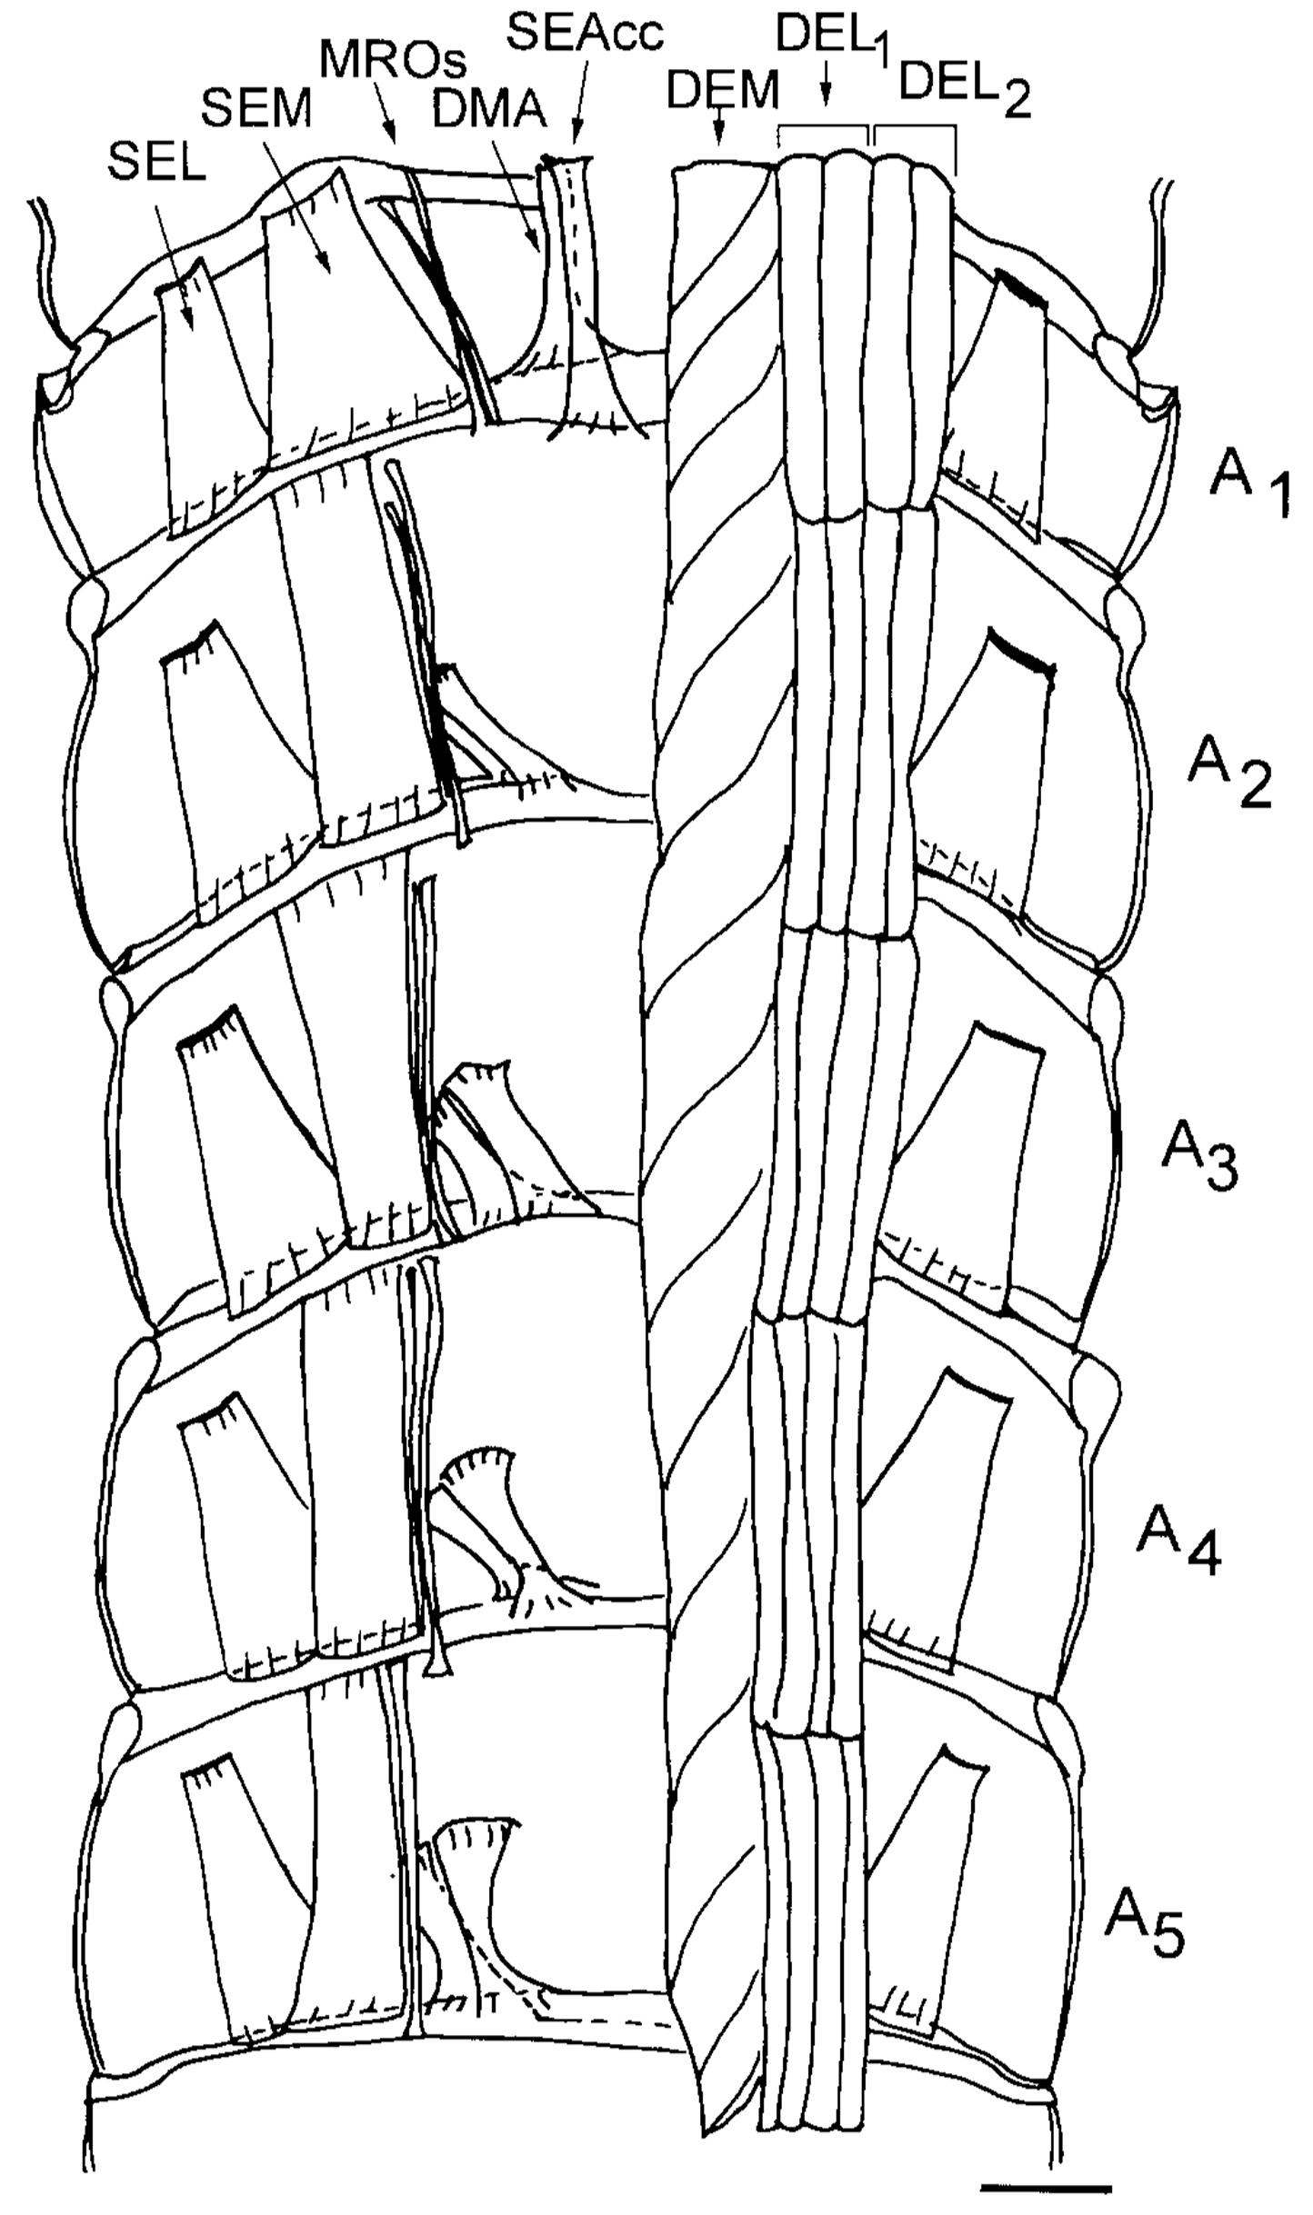
Figure 15. Schematic drawing from a ventral view of the dorsal part of the crayfish abdomen showing the extensor musculature of each segment. The dorsal membrane abdomen muscle (DMA) and the superficial extensor accessory muscle head (SEAcc) occur in segments 1 through 5 of the abdomen with a different orientation for each segment. With the exception of segment 1, these muscles have their attachment sites at their anterior end to the calcified tergite and at the posterior end in the articular membrane. In segment 1, the homologous muscles have their anterior attachment sites to the articular membrane located between the thorax and abdomen. The illustration was based upon photographic montages of methylene blue stained preparations. On the left side of the figure all the deep extensor muscles have been removed to show the dorsal superficial extensor muscles. Scale = 2.35 mm. (Taken from Sohn et al. 2000).

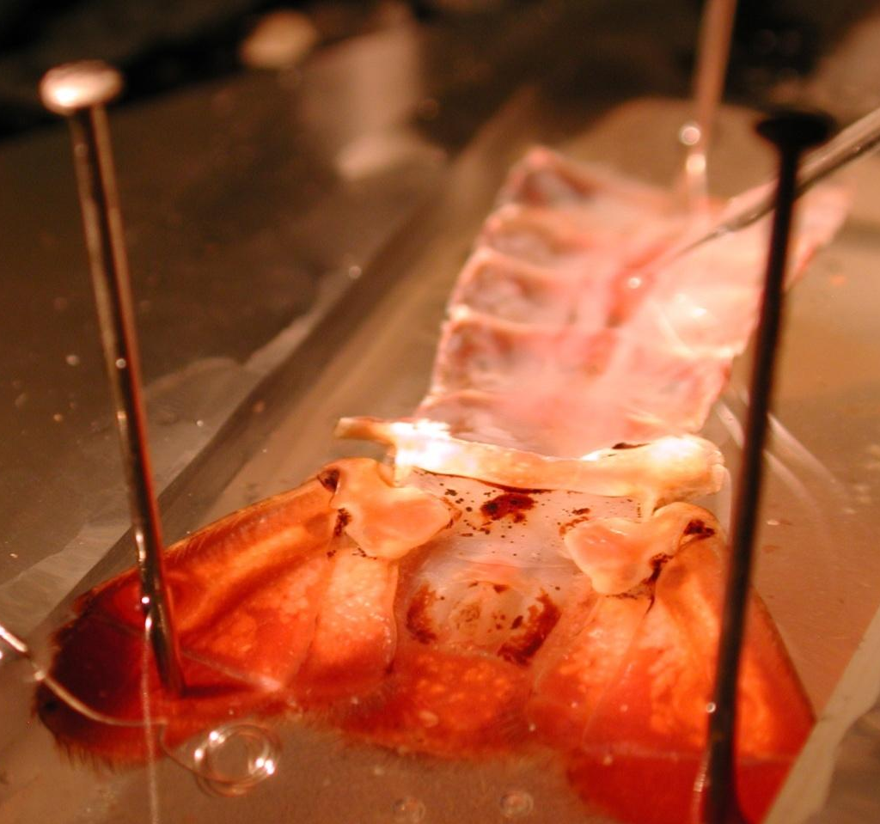
Electrode tip
Figure 16: Insertion of electrode into the muscle of a pinned preparation to the recording dish.

The difference in the computer recorded values might need to be adjusted to account for any amplification used on the amplifier (i.e. 10X amplification). The voltage should be converted to millivolts if the values are reported on the software as volts (1 V = 1,000mV).

17. Carefully use the dissecting scope and micromanipulator to withdraw the electrode from the muscle. Reposition the electrode and insert the tip into another muscle fiber (this can be right next to your previous insertion). Record the resting membrane potential. One should collect several recordings and be comfortable with measures as well as directing the intercellular electrode into the muscle fiber of interest before moving onto the next step

18. The bathing solution can now be exchanged starting with 5.3 mM K⁺ to the series of 10 mM, 20 mM, 30 mM, 40 mM, 50 mM K+ concentrations and then returned to 5.3 mM.

19. After this series of [K⁺] was used then a second and third series was used but at 10ºC then 5ºC and finally at 30ºC. Use the higher temperatures last as they may damage the muscle fiber. A period of 5 minutes was used for initial conditioning to the new temperature before proceeding with the next series of [K⁺] changes.

20. Fill in the table:
[K⁺]_{out} (mM) | Electrode resistance | Membrane potential (mV) | Bathing temperature
5.3 |  |  | 21
10 |  |  | 21
20 |  |  | 21
30 |  |  | 21
40 |  |  | 21
50 |  |  | 21
5.3 |  |  | 10
10 |  |  | 10
20 |  |  | 10
30 |  |  | 10
40 |  |  | 10
50 |  |  | 10
5.3 |  |  | 5
10 |  |  | 5
20 |  |  | 5
30 |  |  | 5
40 |  |  | 5
50 |  |  | 5
5.3 |  |  | 30
10 |  |  | 30
20 |  |  | 30
30 |  |  | 30
40 |  |  | 30
50 |  |  | 30

DISCUSSION AND THOUGHT PROBLEMS
As early as 1902, Bernstein was dealing with the issues of a resting potential in the axon of a squid. It is intriguing to consider how these early ideas and observations of Berstein (1902) and Nernst (1888) later influenced research in membrane physiology. (See review by Malmivuo and Plonsey, 1995; also available on the www http://www.bem.fi/book/ ). There are still, to this day, breakthroughs being made about ion channel function and properties of biological membranes that are very significant in understanding the cellular physiology which relates to the function of tissues, organs and systems.

The comparison of the experimental and theoretically derived effects of external [K⁺] on the resting membrane potential indicates the influence of ions on the membrane potential. Additional experiments using this same preparation remain to be performed to address fundamental physiological questions. Some were highlighted back in 1968 by Atwood and Parnas and have yet to be fully tackled. With the techniques obtained in this exercise, one can proceed to answer many questions remaining in other experimental preparations as well as in physiological applications related to medicine and health. We have demonstrated the usefulness of a model invertebrate preparation to address fundamental questions pertinent to all animals.

With the knowledge gained on the electrochemical gradients of ions in this above exercise, you can now advance to the excitability of membranes by examining synaptic transmission at neuromuscular preparations in the crayfish. One can also apply these concepts on other cell types such as neurons and cardiac tissue.

Concepts to address:

1. Ensure you can determine [K⁺]_{i} given all the other parameters in the Nernst equation.

2. Discuss why the estimated Ek may not match the resting membrane potential measured.

3. Why are the slopes of the lines for the graphs of membrane potential and [K⁺]_{o} not equal at different temperatures?

4. Why are the slopes not linear for the various [K⁺]_{o} ?

5. Address why in the literature are ratios of P_{K}/P_{Na} etc.. used instead of direct values in calculating membrane potential using the G-H-K equation?

One theme was to address the topic of heterothermic animals, such as crustaceans and insects that can be exposed to wide variations in temperature, and the effect of temperature change on excitable cells such as muscle and neurons. So would lowering the body's temperature alter threshold of a neuron or a heart cell? If so, would it be more or less excitable and why? Would the effect be just the opposite in excitability by the same amount if the temperature was raised (explain your reasoning)? Now consider a homeothermic animal such as a hibernating squirrel which can lower its body temperature with the environment. Would a similar effect occur to the cells of the squirrel with changing temperatures? How about the case for a human which functions best around a set temperature?
Therapeutic hypothermia is a type of treatment. It’s sometimes used for people who have a cardiac arrest. Cardiac arrest happens when the heart suddenly stops beating. Once the heart starts beating again, healthcare providers use cooling devices to lower your body temperature for a short time. It’s lowered to around 89°F to 93°F (32°C to 34°C). The treatment usually lasts about 24 hours.
Is this temperature change large enough to affect the resting membrane potential based on your experimental or theoretical/simulated calculations? Maybe plug in the change to the one line simulation provided and determine how much theoretically the membrane potential changed. What effect do you think it would have on membrane excitability?
Consider the following copied from an article (Showman and Wedlick, 1963):
" Conclusion
In summary, we conclude that the local application of cold combined with proprioceptive neuro-muscular facilitation rehabilitation techniques is the most effective measure we have found in the treatment of multiple sclerosis. We have also found that, when mobilization of a joint is required, if there is any muscle spasm, then it seems preferable to precede reeducation techniques by the local application of cold rather than heat. The local application of cold would seem to be the ideal emergency measure in the initial treatment of acute muscle and ligament strains. It is our experience that, to be effective, cold therapy must consist of moist cold applied to the skin itself. The two methods available are either a spray technique or the use of ice and water. If the spray technique is used, then a fluoromethane spray, such as "Sketron", seems on all grounds far preferable to spraying with ethyl chloride; it has the advantage of being applied easily to any site. However, when muscle spasm is severe, we believe that the use of packs soaked in a mixture of ice and water seems to produce more lasting benefit than the local use of a cooling spray."

What might be the logic in physiological concepts of why these cold treatments work for muscle spasms?

You might have seen on TV after major football games the athletes take ice baths. Do you think it is for the same reason to reduce muscle spasms? Are there any other physiological reasons?

Let us now switch over to metabolism of cells and heat production. When electrical activity of a neuron is induced, a rise of CO₂ from cellular metabolism and production of H⁺ occurs. The rapid diffusion of CO₂ across bilipid membranes can influence both intracellular and extracellular pH (Gutknecht et al., 1977). Cellular metabolism would also raise the local temperature, as you likely know well with just a small amount of exercise. So, is the increase in heat more of a positive-feedback or a negative feedback on cellular excitability of neurons and muscle cells? Lastly what might be the logic behind one's brain shutting off if one overheats as well as if it becomes too cold?

REFERENCES

Atwood HL. Membrane physiology of crustacean neurons. In Podesta RB, Ed. Membrane physiology of invertebrates; New York, Marcel Dekker, Inc. 1982; pp.341–407.

Atwood, H.L. and Parnas, I. (1968). Recording from the crayfish abdominal extensor muscle preparation with microelectrodes. In: Experiments in physiology and biochemistry (Kerkut GA, ed), pp 307-330. London: Academic.

Baierlein, B., Thurow, A. L., Atwood, H. L., & Cooper, R. L. (2011). Membrane potentials, synaptic responses, neuronal circuitry, neuromodulation and muscle histology using the crayfish: Student laboratory exercises, Journal of Visualized Experiments, 47, Retrieved from https://www.jove.com/Details.php?ID =, 2322

Bernstein J (1902): Untersuchungen zur Termodynamik der bioelektrischen Ströme. Pflüger Arch. ges. Physiol. 9: 521-62.

Cooper, R.L. Thenappan, A. and Dupont-Versteegden, E.E. (2019) Examining motor and sensory units as an educational model for understanding the impact of localized tissue injury on healthy cells. Article 6. In: McMahon K, editor. Tested studies for laboratory teaching. Volume 40. Proceedings of the 39th Conference of the Association for Biology Laboratory Education (ABLE). Vol. 40, Article 6, 2019
Fischbarg J. (1972). Ionic permeability changes as the basis of the thermal dependence of the resting potential in barnacle muscle fibres. The J. Physiol. 224(1):149–171.

Goldman DE (1943): Potential, impedance, and rectification in membranes. J. Gen. Physiol. 27: 37-60.

Gutknecht, J., Bisson, M. A., Tosteson, F. C. (1977). Diffusion of carbon dioxide through lipid bilayer membranes: effects of carbonic anhydrase, bicarbonate, and unstirred layers. J Gen Physiol, 69(6): 779-794.

Hille B (1992): Ionic Channels of Excitable Membranes, 2nd ed., Sinauer Assoc., Sunderland, Mass.

Hodgkin AL, Huxley AF (1952): A quantitative description of membrane current and its application to conduction and excitation in nerve. J. Physiol. (Lond.) 117: 500-44.

Hodgkin AL, Huxley AF, Katz B (1952): Measurement of current-voltage relations in the membrane of the giant axon of Loligo. J. Physiol. (Lond.) 116: 424-48.

Hodgkin AL, Katz B (1949): The effect of sodium ions on the electrical activity of the giant axon of the squid. J. Physiol. (Lond.) 108: 37-77.

Johnson BR, Wyttenbach RA, Hoy RR. 2014. Cruataceans as model systems for teaching neuroscience: past, present, and future. In: Nervous systems and control of behavior, the natural history of the Crustacea. (Derby C, Thiel M, eds). New York, NY: Oxford University Press.

Katz, G.M., Reuben, J.P., MacBerman, Dunham, P.B. (1972) Potassium redistribution and water movement in crayfish muscle fibers. J. Comp. Physiol. 80: 267–283).
Malloy, C., Dayaram,V., Martha, S., Alvarez, B., Chukwudolue, I., Dabbain, N., D.mahmood, D., Goleva, S., Hickey, T., Ho, A., King, M., Kington, P., Mattingly, M., Potter, S., Simpson, L., Spence, A., Uradu, H., Van Doorn, J.L., Weineck, K. and Cooper, R.L. (2017). The effects of neighboring muscle injury on proprioception responses in crayfish and crab. J. of Exp. Zoology. 327(6):366–379
Nernst WH (1888): Zur Kinetik der Lösung befindlichen Körper: Theorie der Diffusion. Z. Phys. Chem. 3: 613-37.

Nernst WH (1889): Die elektromotorische Wirksamkeit der Ionen. Z. Phys. Chem. 4: 129-81.

Malmivuo, J. and Plonsey, R. (1995) Bioelectromagnetism- Principles and Applications of Bioelectric and Biomagnetic Fields. New York: Oxford University Press
Showman, J.; Wedlick L.T., The use of cold instead of heat for the relief of muscle spasm. Med. J. Aust. 1963; 2:612-614

Sohn, J., Mykles, D.L., and Cooper, R.L. (2000). The anatomical, physiological and biochemical characterization of muscles associated with the articulating membrane in the dorsal surface of the crayfish abdomen. Journal of Experimental Zoology 287:353-377.

Thenappan, A., Dupont-Versteegden, E.E. and Cooper, R.L. (2019) An educational model for understanding acute deep tissue injury of motor units. Journal of Young Investigators 36(5): 62-71.
Van Harreveld, A. (1936) A physiological solution for freshwater crustaceans. Proc. Soc Exp. Biol. Med. 34: 428-432.

Wyttenbach RA, Johnson BR, Hoy RR. 1999. Crawdad. A CD-ROM Lab manual for neurophysiology. Sunderland, MA: Sinauer Associates.

Student assessment

Preliminary results indicate significant learning increases. Student participants (n=17, matched), in an Animal Physiology course (BIO350) at the University of Kentucky, were asked to complete a pre- and post-survey assessing students’ learning outcomes related to the resting membrane potential (RMP). When asked about RMP and ion distribution, participants demonstrated a significant increase (p=0.002) in content understanding. Additionally, when asked about describing and performing calculations of RMPs, participants showed a significant increase (p<0.001) in their confidence levels. These data suggest that participation in a resting membrane laboratory exercise increases student content understanding and confidence about RMPs.

General Assessment Questions
The following questions were used as a pre-survey:
1. What ions are higher in concentration inside the skeletal muscle cytoplasm, when at a resting state, as compared to the extracellular fluid around a skeletal muscle?
A. Ca2+
B. Na+
C. K+
D. Cl-
E. I am not sure.

2. Invertebrates (such as a crayfish) can serve as a model to address some physiological phenomena in relation to mammals?
A. True
B. False

3. Which description below best describes what happens to the membrane potential when K+ ions increase (for example from 5 mM to 50 mM) in the extracellular fluid around a mammalian skeletal muscle?
A. The resting membrane potential of the muscle will not change.
B. The resting membrane potential of the muscle will hyperpolarize (become more negative).
C. The resting membrane potential of the muscle will depolarize (become more positive).
D. I am not sure.

4. Have you used the Nernst equation or the Goldman-Hodgkin-Katz equation to help in understanding the membrane potential of cells prior to this course?
A. Yes
B. No

5. When and invertebrate like a crayfish or an insect goes from a warm environment to a cold environment or the temperature around them changes from warm to cold what do you think will happen to the resting membrane potential of the muscle fibers
A. depolarizes
B. Hyperpolarize
C. does not change

Please explain your answer for question 5.

6. (Short answer)
Therapeutic hypothermia is a type of treatment. It’s sometimes used for people who have a cardiac arrest. Cardiac arrest happens when the heart suddenly stops beating. Once the heart starts beating again, healthcare providers use cooling devices to lower your body temperature for a short time. It’s lowered to around 89°F to 93°F (32°C to 34°C). The treatment usually lasts about 24 hours.
During cardiac arrest, blood doesn’t flow to the organs of the body. The brain may also not get enough blood. That’s why many people don’t recover after cardiac arrest. The lack of blood flow can cause lasting damage to the brain. The person may be unable to regain consciousness. Lowering the body temperature right away after cardiac arrest can reduce damage to the brain. That raises the chances that the person will recover.
Therapeutic hypothermia can help only some people who have had cardiac arrest. Therapeutic hypothermia can be a good choice if the heart restarted but if one is still not responsive. It can raise the chance that you will wake up.

How might lowering the body’s temperature reduces brain damage and improve survival in your view?

The post-survey after completing the laboratory exercise
General assessment questions (mark A, B, C, D or E after each point)
Part 1. On a scale of 1 – 5: (A) Strongly agree, (B) Agree, (C) Neutral, (D) Disagree, (E) Strongly disagree:
- This exercise increased my interests in knowing more about how tissue injury can affect whole body health in humans.
- This exercise increased my understanding of the scientific method.
- This exercise helped me to understand how the membrane potential is altered by temperature in muscle and neurons.
- I have a better understanding of the physiological conditions that heterothermic (cold blooded) animals might have to deal with in their environment related to temperature changes.
- After conducting this exercise, I feel comfortable developing my own hypotheses to address questions related to physiological functions of resting membrane potential of cells
- After conducting this exercise, I feel confident that I can develop an experiment to test a hypothesis in a quantitative manner
- After conducting this exercise, I feel confident conducting basic data analysis and summarization
- I understand that ionic compounds inside cells that spill out during injury can be related to injury in other cells.
- I feel comfortable developing a muscle fiber electrophysiological recording as part of an experimental study.
- I feel more confident in my note taking abilities, and my ability to summarize general scientific trends
Part 2 (same questions as the 1st assessment but seeing if one has a different understanding now after conducting a laboratory exercise on this topic)
1. What ions are higher in concentration inside the skeletal muscle cytoplasm, when at a resting state, as compared to the extracellular fluid around a skeletal muscle?
A. Ca2+
B. Na+
C. K+
D. Cl-
E. I am not sure.

2. Invertebrates (such as a crayfish) can serve as a model to address some physiological phenomena in relation to mammals?
A. True
B. False

3. Which description below best describes what happens to the membrane potential when K+ ions increase (for example from 5 mM to 50 mM) in the extracellular fluid around a mammalian skeletal muscle?
A. The resting membrane potential of the muscle will not change.
B. The resting membrane potential of the muscle will hyperpolarize (become more negative).
C. The resting membrane potential of the muscle will depolarize (become more positive).
D. I am not sure.

4. Have you used the Nernst equation or the Goldman-Hodgkin-Katz equation to help in understanding the membrane potential of cells prior to this course?
A. Yes
B. No

5. When and invertebrate like a crayfish or an insect goes from a warm environment to a cold environment or the temperature around them changes from warm to cold what do you think will happen to the resting membrane potential of the muscle fibers
A. depolarizes
B. Hyperpolarize
C. does not change

Please explain your answer for question 5.

6. (Short answer)
Therapeutic hypothermia is a type of treatment. It’s sometimes used for people who have a cardiac arrest. Cardiac arrest happens when the heart suddenly stops beating. Once the heart starts beating again, healthcare providers use cooling devices to lower your body temperature for a short time. It’s lowered to around 89°F to 93°F (32°C to 34°C). The treatment usually lasts about 24 hours.
During cardiac arrest, blood doesn’t flow to the organs of the body. The brain may also not get enough blood. That’s why many people don’t recover after cardiac arrest. The lack of blood flow can cause lasting damage to the brain. The person may be unable to regain consciousness. Lowering the body temperature right away after cardiac arrest can reduce damage to the brain. That raises the chances that the person will recover.
Therapeutic hypothermia can help only some people who have had cardiac arrest. Therapeutic hypothermia can be a good choice if the heart restarted but if one is still not responsive. It can raise the chance that you will wake up.

How might lowering the body’s temperature reduces brain damage and improve survival in your view?

Sample results obtained by the students

Computational data
Student obtained graphical analysis of the computational obtained data for four different temperatures and varying [K⁺]_{o}. This data is also presented in tabular form in supplemental information for instructors to use as they wish for their classes.
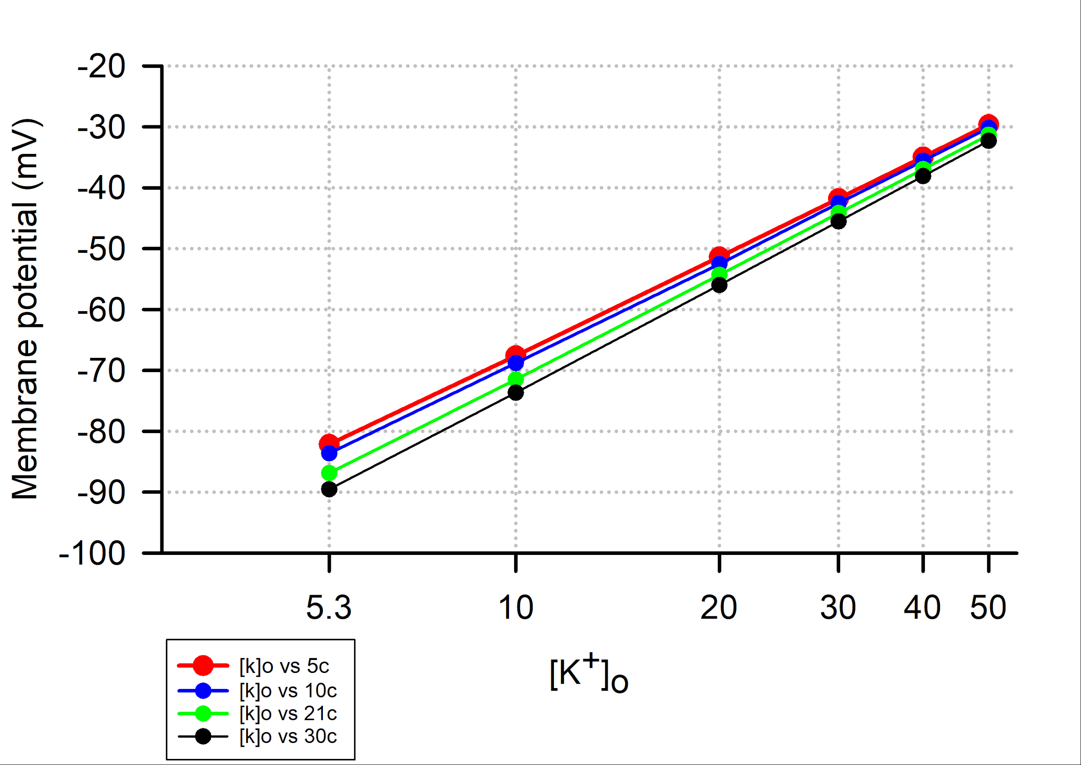

Experimental results
Half the of the class examined the membrane potential at room temperature 21ºC with altering the [K⁺]_{out} and again at 5ºC in one lab setting and other half of the class used 21ºC with altering the [K⁺]_{out} and again at 30ºC. The individual graphs of each student's results are shown below. Linear regression lines are shown for some graphs of the data which indicated a linear relationship.
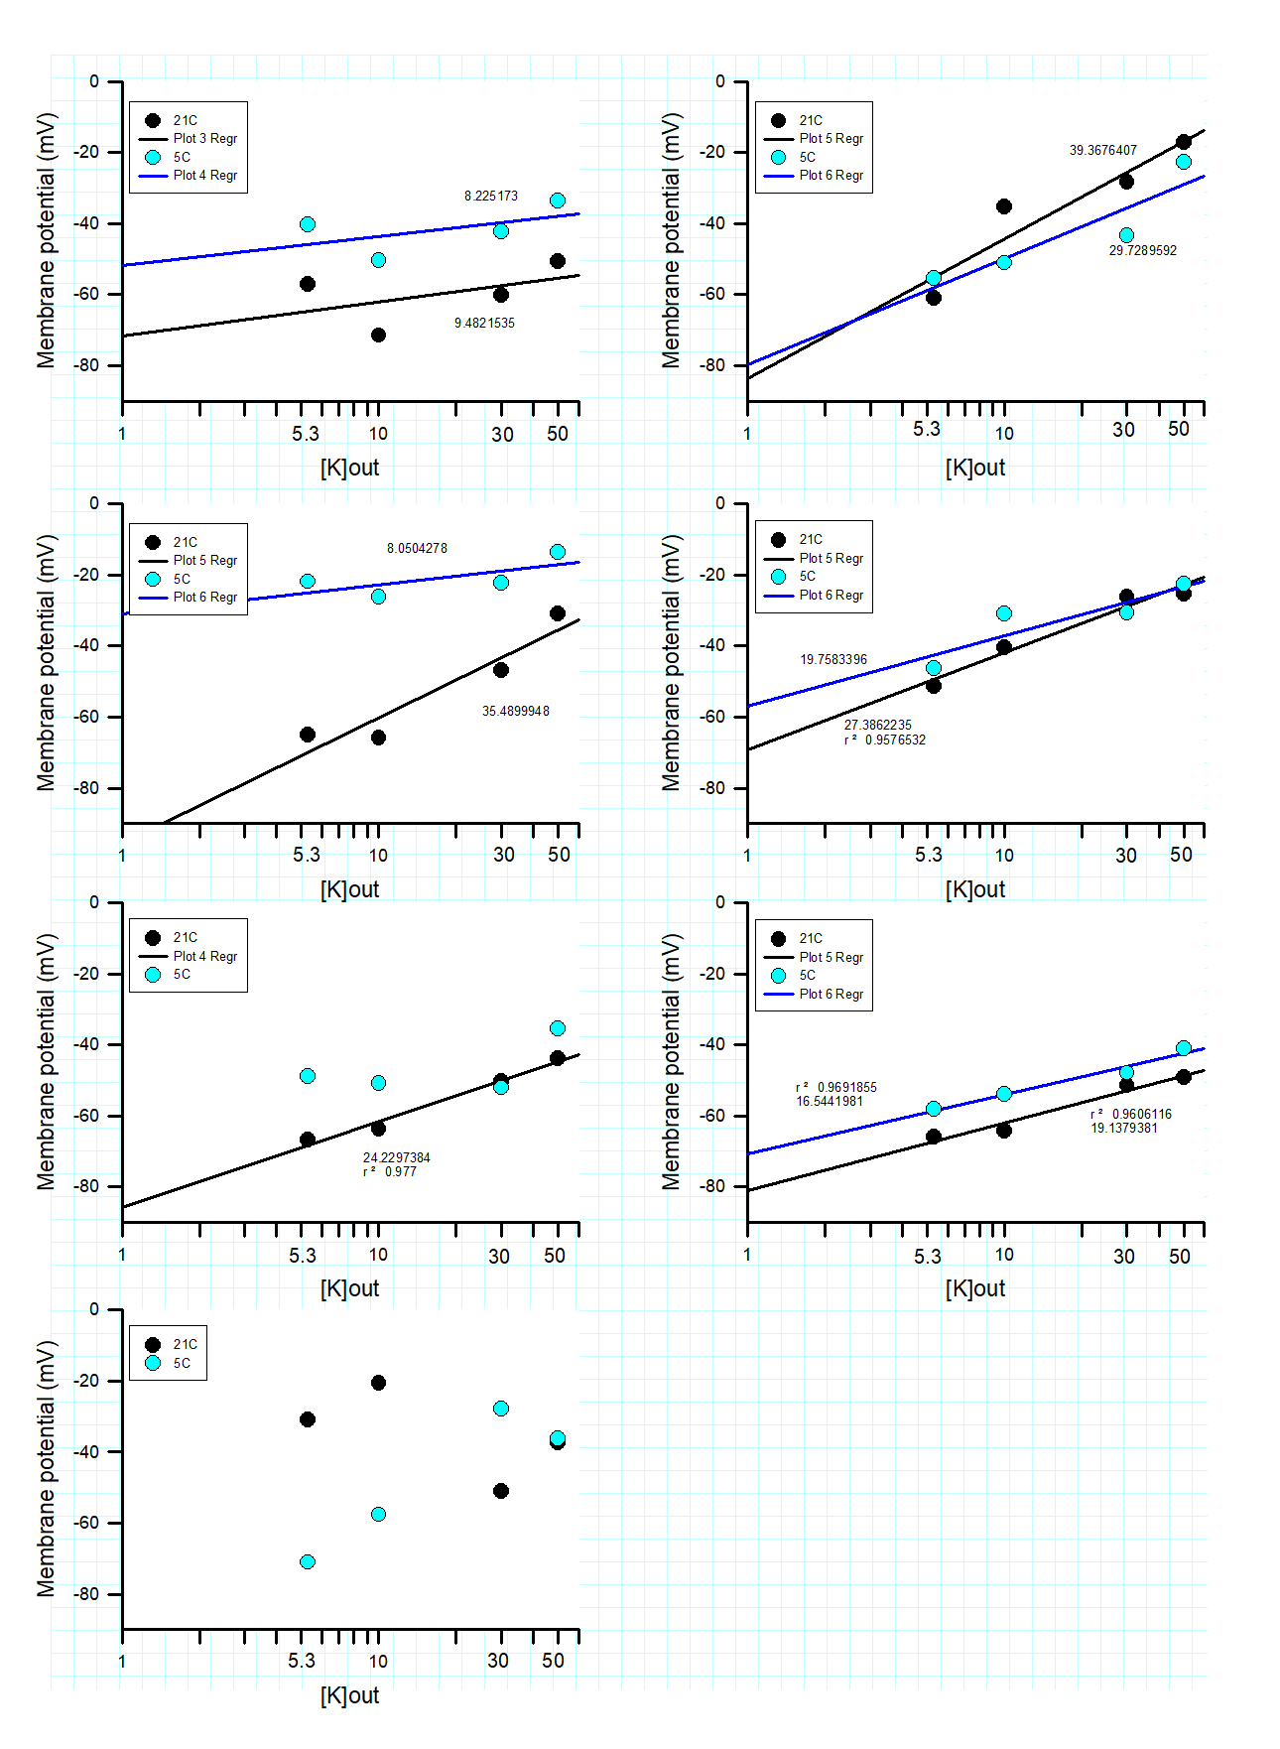
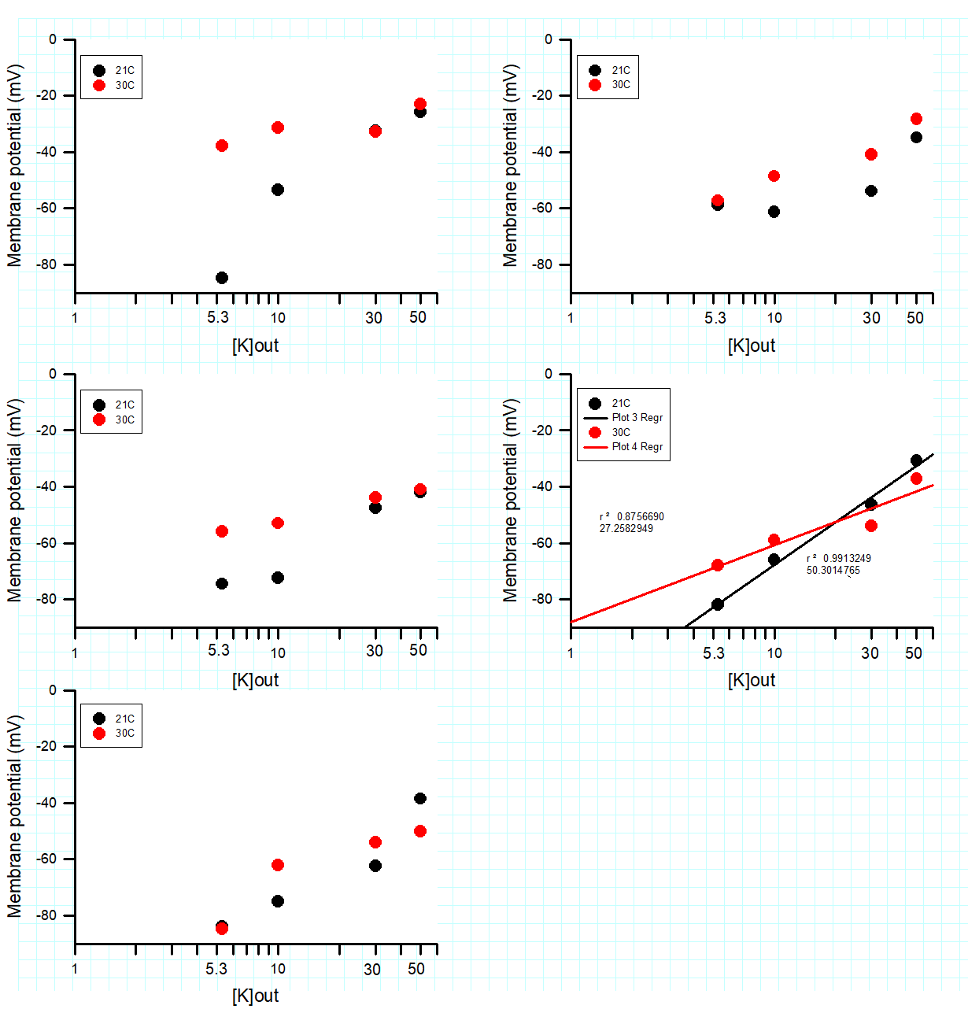

Notes for the Instructor

Throughout this exercise, the students are focused on being able to determine how the external concentrations of K⁺ affects the membrane potential and that this effect also varies with temperature. When using the Goldman-Hodgkins-Katz (G-H-K) equation to determine the theoretical resting membrane potentials, the estimated values may differ from the values being physically measured. Routinely the normal membrane potential found by students was approximately 50mV. The students should not be discouraged if their values are not close to the predicted values. This can be due to several different factors in relation to temperature, such as small changes in permeability in the ion leak channels, the external environment of the membrane differing from our expectations, the effect on the pumps (i.e., Na-K ATP pump) and exchangers as well as alteration in pH which also can have an effect on membrane potential. As mentioned in the Fischbarg (1972) study of muscles in barnacles, the author states the differences from theoretical values are likey due to alteration in permeability of the potassium leak channels. If the students were so inclined, they could try different values of permeability in the simulation at the higher temperatures to try to fit the theoretical values to the experimental measures.
By having the students run through the simulation prior to the experimentation the understanding in that temperature is critical in altering the membrane potential, students noted an emphasis to exchange the bathing solution twice or three times and record the measures within a few minutes. In addition, students realized spurious data points will make it hard to graph the data so some students took care in obtaining an average membrane potential by recording two or three fibers quickly at each condition.
The concerns with using the simulation is having values to use for intracellular ion concentrations. There are few student friendly experimental tissues with reported values in the literature. This did bring up conversations how did researchers come up with the values to use. Even in the well-studied crayfish skeletal muscles differing values are reported for internal K⁺ and Na⁺ concentrations. This also brought up discussion point on different cell types if the ionic concentrations are similar. This then lead back to why some cells have varied resting membrane potentials and different equilibrium potentials for the ions compared to other cells. It was surprising to some students that researchers have not determined ionic concentrations in tissues of mammals. It was also a surprising for some when discussing skeletal muscle for Drosophila that the equilibrium potential for Cl⁻ ions is a value more depolarized than the resting membrane potential (Rose et al., 2007). A discussion on how the values of permeability of the ions is obtained was also a discussion point. Thus, an appreciation of the past research and amount of research required to determine such parameters began to be understood by the students. The realization that the squid axon was a fundamental preparation as one could exchange the internal and external ionic concentration and alter membrane potentials to calculate equilibrium potential was a point well driven with guided flow by the instructors.
As for the implementation of the experimental collection of data in a large class setting it is hard to maintain temperature in the recording dishes. It would be useful to have a thermometer at each recording setup so a recording can be made while the membrane potential is recorded. The other issue in implementing this exercise if the breaking of the electrode tip in the recording dish. Sometimes the electrode tip may hit the cuticle or a dissection pin and the 3 mM KCl can leak out over the preparation before one has time to exchange the bathing media out with fresh saline.
It was observed some students tried to keep the electrode in a muscle fiber while exchanging the bathing media. This may lead to inaccurate recordings due to alterations in the zero offset of the electrode and not testing if the tip of the electrode had be broken with the potential of the muscle twitching while exchanging the bath. It would be best to remove the electrode from the muscle fiber and re-zeroing the potential as well as testing the electrode resistance prior to taking the next recording. In addition, taking an average of three recordings in different muscle fibers for each setting is beneficial for knowing if a data point is spurious.
Graphing the simulated and experimental data required some discussion for students to understand there are various ways the concept is presented in the literature and textbooks. Some reports only indicate a difference in the membrane potential without the absolute values being reported. Also, some reports show a change as increasing on the y-Axis with hyperpolarization which can be confusing. It may be useful to indicate reporting values on the y-Axis as the absolute membrane potential as negative values indicated in a downward and depolarization in increasing in an upward direction. In addition, published reports sometimes indicate a ratio of [K]out/ [K]in as compared to only [K]out.
In discussing practical applications of this laboratory exercise a theme of using poikilotherms and environmental changes in temperature effects on the membrane potential is readily understood. A discussion in ionic and osmolarity changes with seasonal changes in temperature for insects is an interesting topic for more discussion and searching the primary literature for students in writing their lab reports. Moving the discussion from poikilotherms to homeotherms which are true hibernators which drop their body temperature along with environmental temperature draws attention to this exercise. Ideas were discussed of measuring membrane potentials in cells for hibernators and non-hibernators to see if there are differences in adaptation among species at different temperatures.

Many of the life science undergraduate students are interested in health care as a future career. To pique an interest in these students a discussion in the use of therapeutic hypothermia used in humans to recover from heart attacks, strokes, brain damage or after brain surgery to generally prevent the brain from further damage or insult was approached. The concept in using therapeutic hypothermia is basically to reduce metabolism and swelling of neural tissue until sometime has occurred to reduce the initial trauma. However, physicians do not want to reduce body temperature too much as the heart can become arrhythmic and can even stop beating. The mechanism of why the heart stops beating when exposed to cold has yet to be determined. However, if Ca2+ ions are allowed to flux across the cardiac cells, as examined in hearts of larval Drosophila in the cold in which the heartbeat has stopped, rejuvenates the heart to beat again. Such studies in larval Drosophila were conducted with optogenetic techniques (Zhu et al., 2016a,b), which demonstrated that the mechanical ability of the heart to beat is possible in the cold but it is likely the ion channels where not functioning in the cold environment and the membrane potentials were likely alerted by the cold which blocked the pacemaker activity in the larval hearts.

References
Cooper, R.L. Thenappan, A. and Dupont-Versteegden, E.E. (2019) Examining motor and sensory units as an educational model for understanding the impact of localized tissue injury on healthy cells. Article 6. In: McMahon K, editor. Tested studies for laboratory teaching. Volume 40. Proceedings of the 39th Conference of the Association for Biology Laboratory Education (ABLE). Vol. 40, Article 6, 2019
Fischbarg J. (1972). Ionic permeability changes as the basis of the thermal dependence of the resting potential in barnacle muscle fibres. The J. Physiol. 224(1):149–171.

Malloy, C., Dayaram,V., Martha, S., Alvarez, B., Chukwudolue, I., Dabbain, N., D.mahmood, D., Goleva, S., Hickey, T., Ho, A., King, M., Kington, P., Mattingly, M., Potter, S., Simpson, L., Spence, A., Uradu, H., Van Doorn, J.L., Weineck, K. and Cooper, R.L. (2017). The effects of neighboring muscle injury on proprioception responses in crayfish and crab. J. of Exp. Zoology. 327(6):366–379
Pross, A. (2012) What is Life?: How Chemistry Becomes Biology. Oxford Landmark Science. OUP Oxford, ISBN 0191650897, 9780191650895.

Thenappan, A., Dupont-Versteegden, E.E. and Cooper, R.L. (2019) An educational model for understanding acute deep tissue injury of motor units. Journal of Young Investigators 36(5): 62-71.

